When you goto a website like this http://www.britishairways.com/travel/routeintro/public/en_us
You will see
1) URL
2) Tab
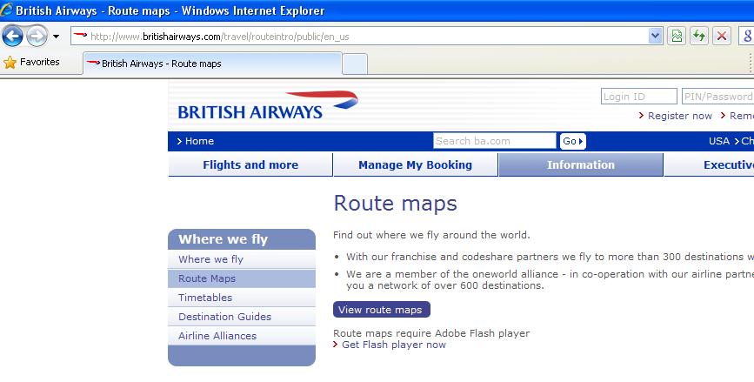
When you click link (image) “View Route Maps” – a new page will open without URL and TAB - without any Internet browser options as shown below
